**TODAY’S OBJECTIVE IS DETAIL EXPLANATION ABOUT THE BELOW TOPICS:**

**Measures of Central Tendency(First Moment Business Decision):**

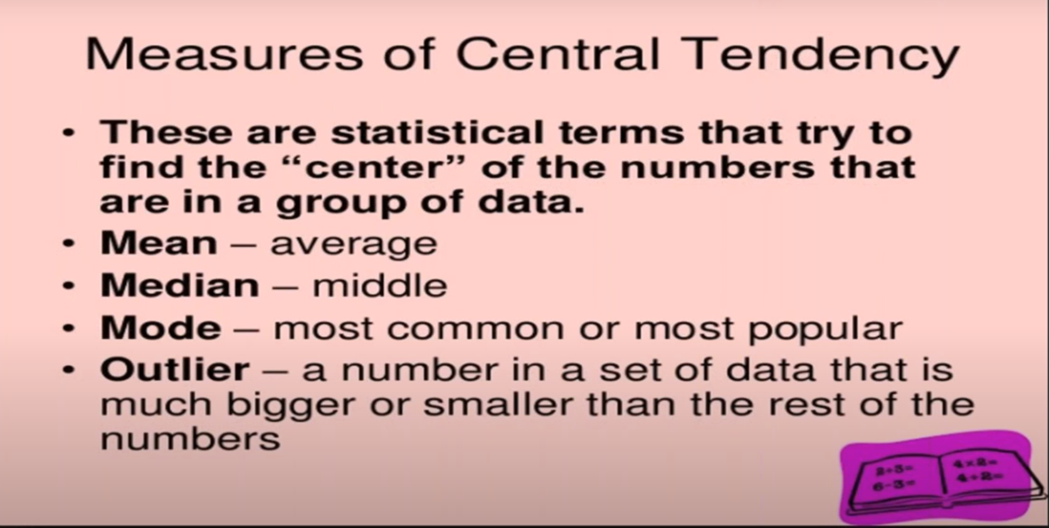

What is your average profit?

What is your average revenue?

What is your average sales?

What is your average loss?

**Mean(Average)**:

The sum of all values divided by the number of values.

Average of 1 2 3 4 5 → 3

What does this 3 indicate? → More amount of values are present around 3

Average of 1 2 3 4 700 → 142

What does this Average=142 indicate? → More amounts of values are present around 142. But in our example, there are no values near to 142

The average has been impacted to a greater extent because of one value 700.

This 700 can be called an extreme number(upper extreme number). This extreme number in terms of Data Science is called an Outlier.

Outliers can be a lower extreme number or an upper extreme number.

And not always an extreme value can be called an outlier, we can have some genuine data.

Average can be influenced by outliers.

**Median:**

The value such that one-half of the data lies above and below. It is also called the 50th percentile.

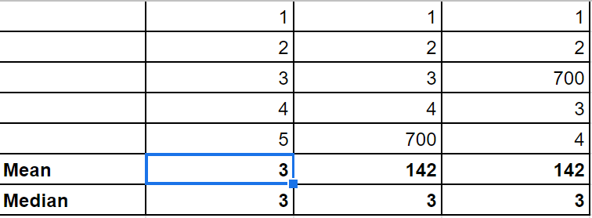

While calculation of Median, data will be sorted either in ascending order or descending order. What this indicates is, median is not influenced by outliers. To lessen the impact of outliers, we usually prefer Median.

**Mode:**

Average cannot be calculated for categorical data.

For non-numerical data i.e., the categorical data we can measure with Mode in the distribution-- the most repeated value or most occurrence value in the data

If we have a single-mode→ We call it a Unimode.

If we have two modes→ We call it as Bimode

If more than two modes→ We call it as Multimode

Example: Sunny→ 5 times(one mode)

Sunny and Rainy→ 4times

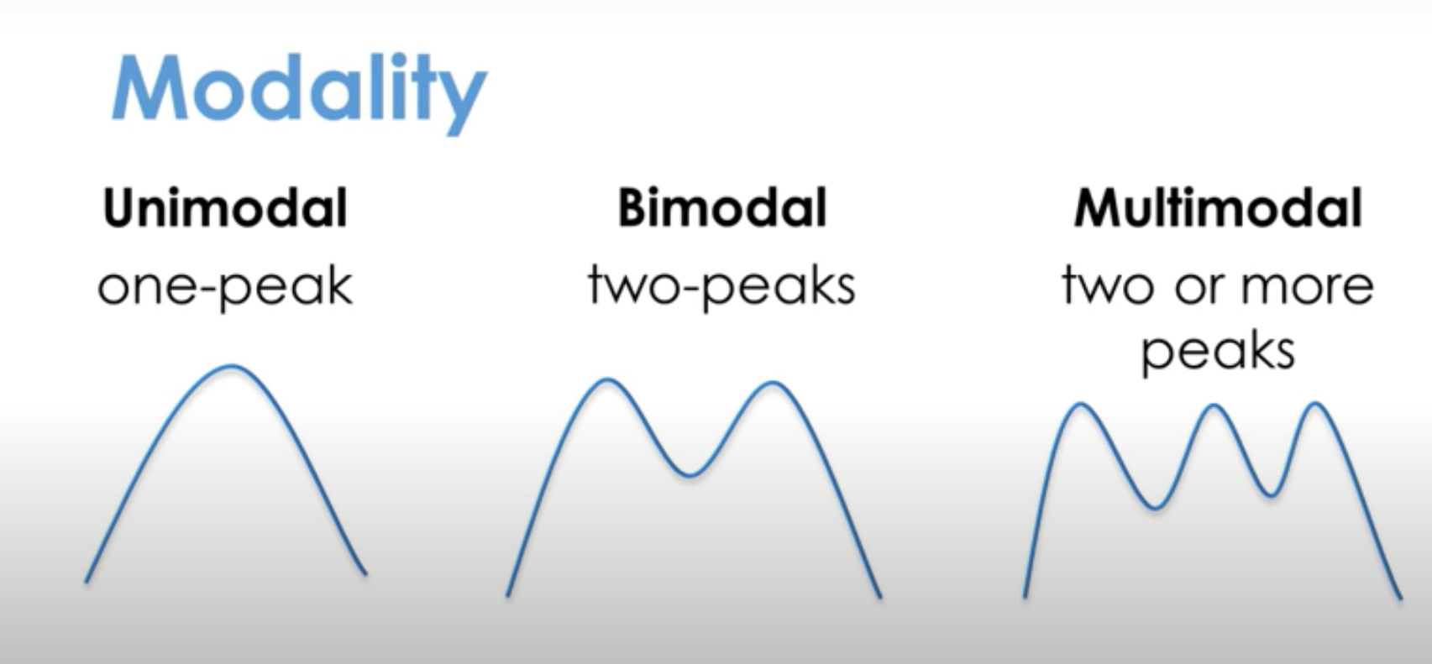

**Outlier:**

A data value that is very different from most of the data

**Second Moment Business Decision:**

The measure of variation in the dataset is called the Measures of Dispersion.

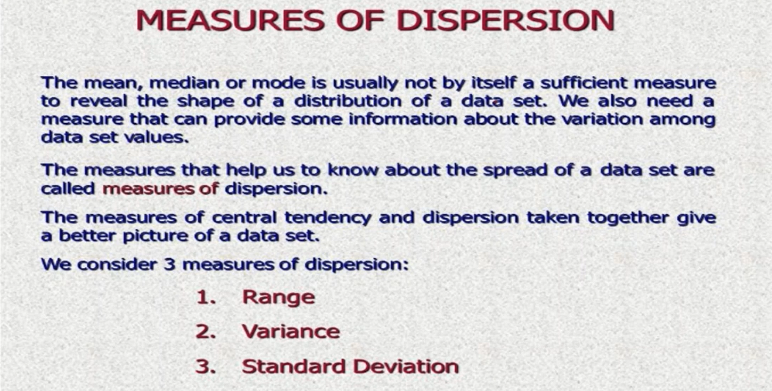

**Range**:

The difference between the largest and the smallest value in a data set.

**Variance:**

It shows the measure of spread in the data.

The variance is the average of the squared differences from the mean. To figure out the variance, first calculate the difference between each point and the mean; then, square and average of the results.

Example: Weights of different Products 1 2 3 4 5 → Mean=3

Variance = ⅕[(1-3)^2 + (2-3)^2 + (3-3)^2 +(4-3)^2 +(5-3)^2] = **2.5**

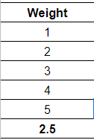

**Standard Deviation:**

Standard Deviation looks at how spread out a group of numbers is from the mean, by looking at the square root of the variance. It helps us visualize how much variation exists in the data distribution.

It is a number or a quantity expressed by how much the data points differ from the mean.

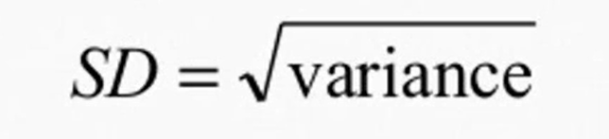

Why do we go for Standard Deviation, what is the need?

While calculating variance, units also get squared. In order to overcome the units getting squared we use the square root.

**Normal Distribution:**

Also called Gaussian Distribution.

It is a special type of curve that is bell-shaped.

For this reason, Normal Distribution is sometimes called the bell curve or the normal curve. The Normal Distribution and its shape actually arises from many different variables found in nature such as weight, height, volume, Blood Pressure and many more.

Normal Distribution describes the tendency to cluster around a central value. In fact, the central value is called Mean, which is located in the middle of the curve.

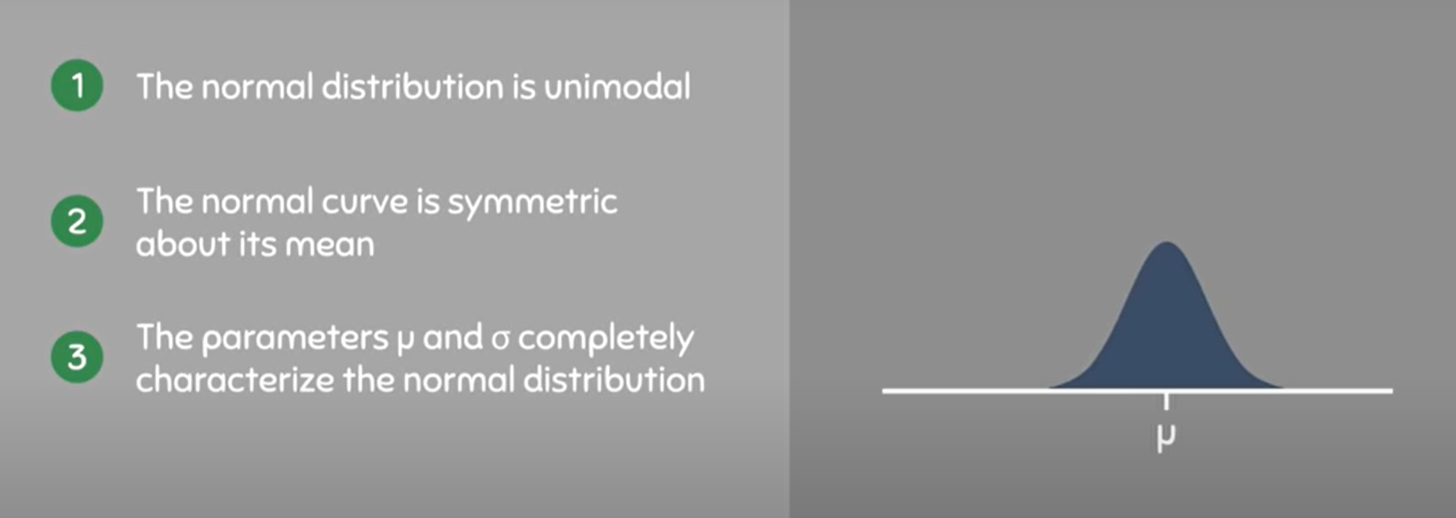

For any Normal Distribution, we can say that some data points will fall below the mean and some data points will fall above the mean. But, most of the data points are located near the mean.

**Example:**

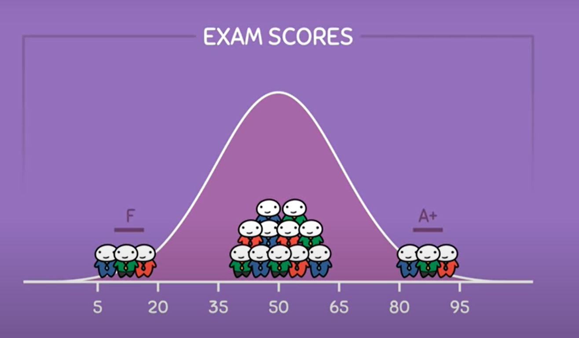

The Mean characterizes the position of the Normal Distribution. If we increase the mean, the curve will follow and moves towards the right side and if we decrease the mean the curve will still follow and move towards the left

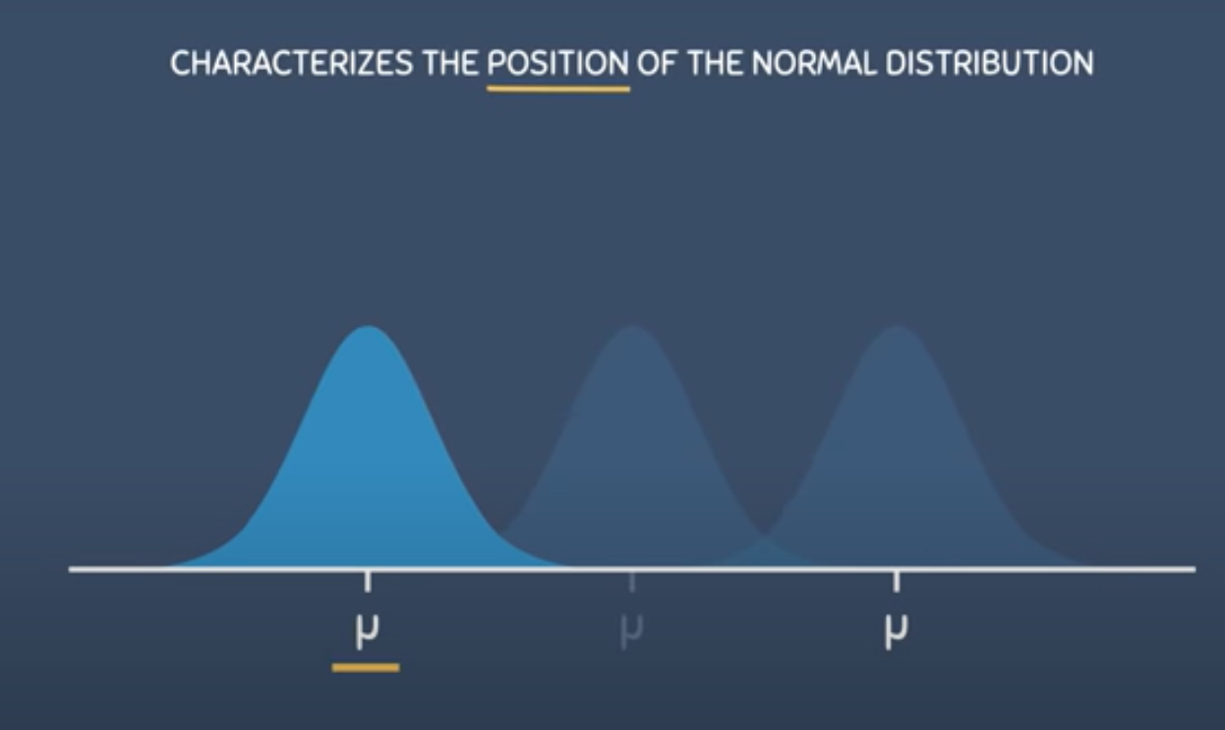

This happens because the data will always cluster around the mean in a normally distributed population, as a result the value of the mean decides the position of the Normal Distribution.

The Standard Deviation characterizes the spread of Normal Distribution. The larger the Standard Deviation, the more spread of the distribution will be. When the spread increases the curve gets much flatter and when the spread decreases the curve gets taller

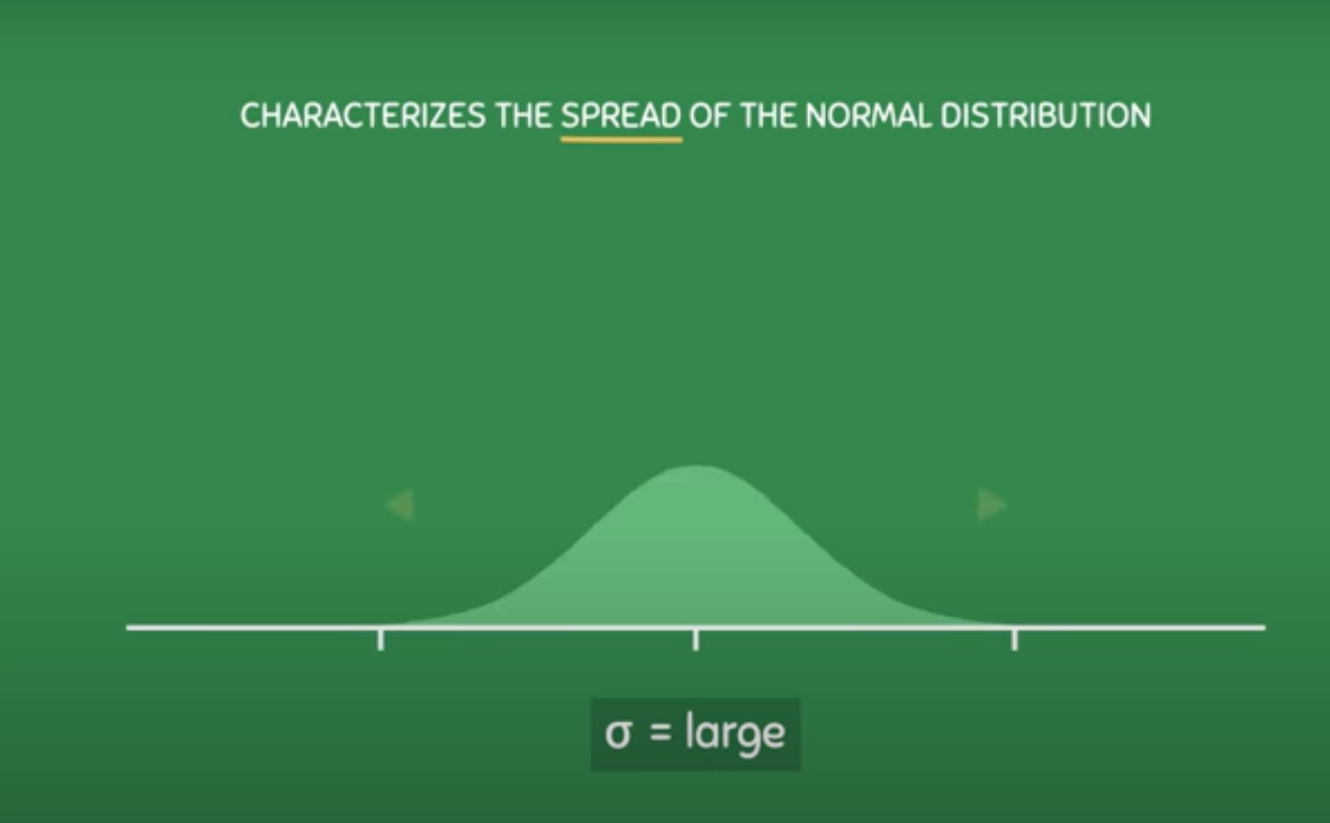

When the Standard Deviation is less, the distribution will appear as below:

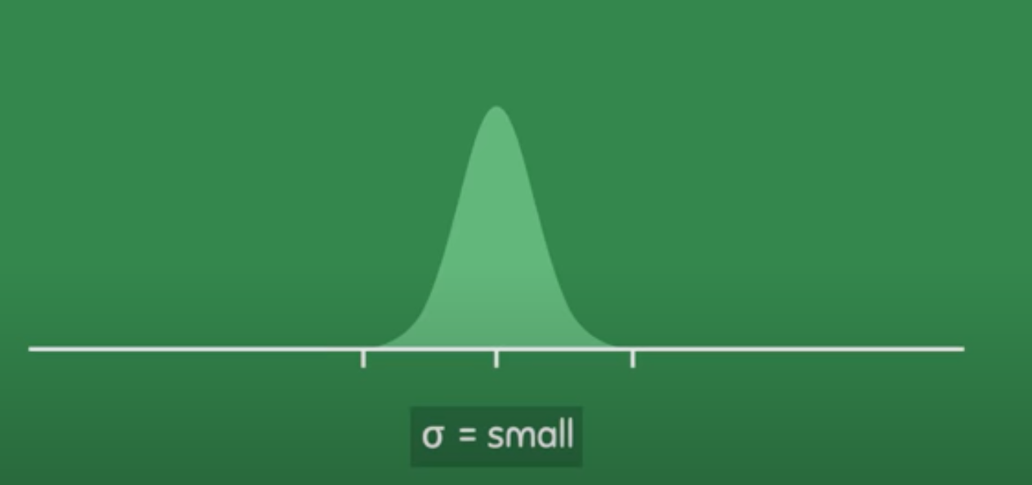

The reason for this is, ND is a density curve and the total area under the curve must remain equal to 1 or 100%. So, changes in the width of the curve must be compensated for by changes in the height of the curve and vice-versa.

The Mean determines the location of the distribution and where the data tends to cluster around.

The Standard Deviation determines how spread out the distribution would be.

**68-95-99.7 Rule:(Empirical Rule)**

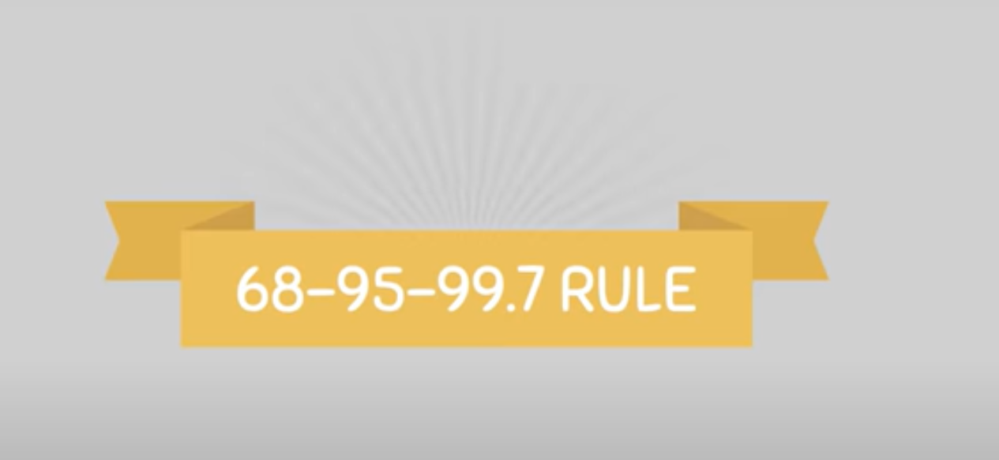

It is a great way to approximate the areas of a Normal Distribution.

Example: Measuring heights of all the students at a University, and found that it was normally distributed with a mean height of 5.5feet and a standard deviation of 0.5, we can construct a Normal Distribution as follows:

Consider Mean as 5.5 and Standard Deviation as 0.5

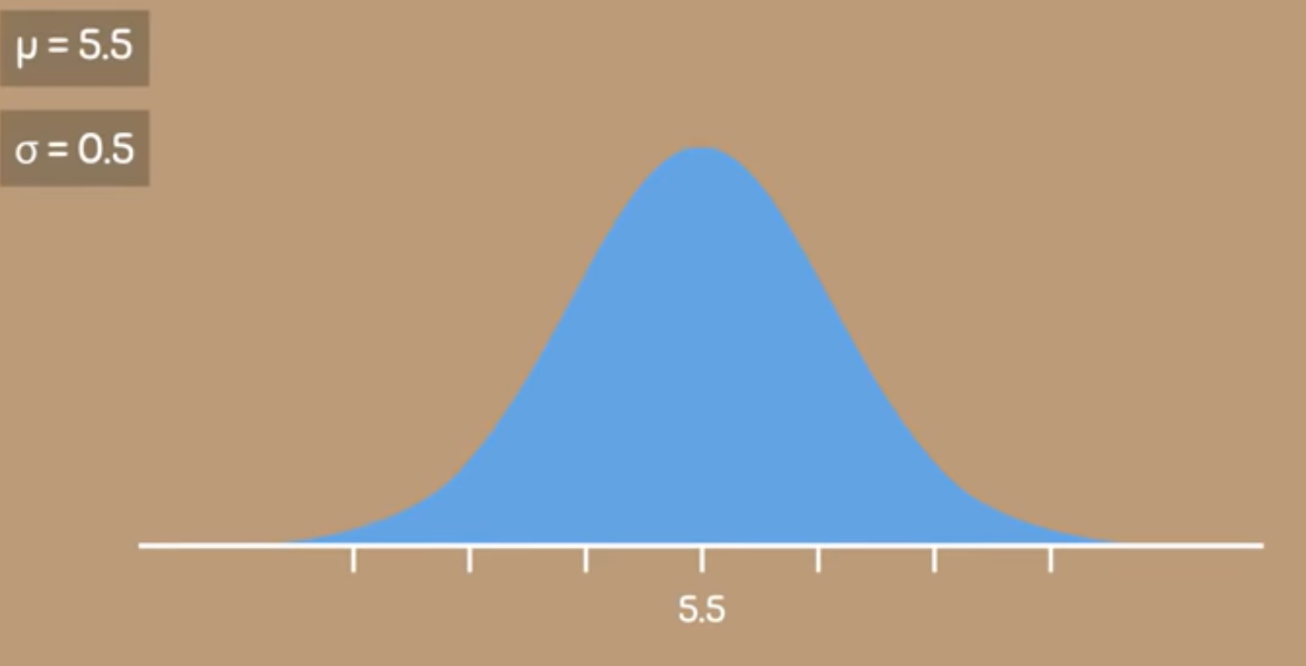

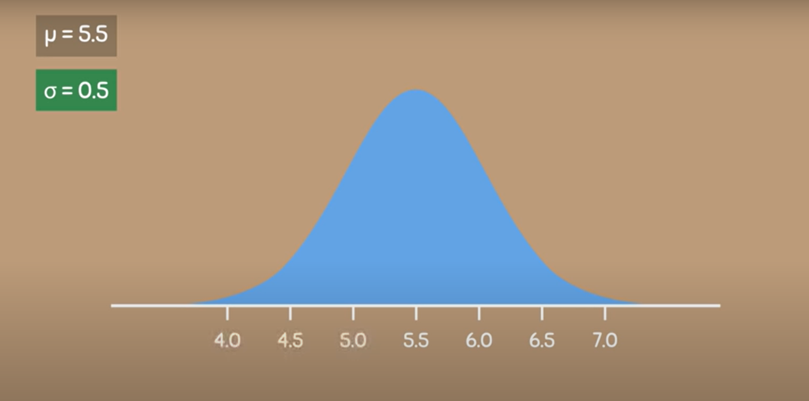

From the rule of 68-95-99.7 Rule, it is said that within 1 Standard Deviation away from the mean, it contains a total area of 68% or 0.68%. Because of this, we can say that 68% of the total population are between 5 and 6 feet tall.

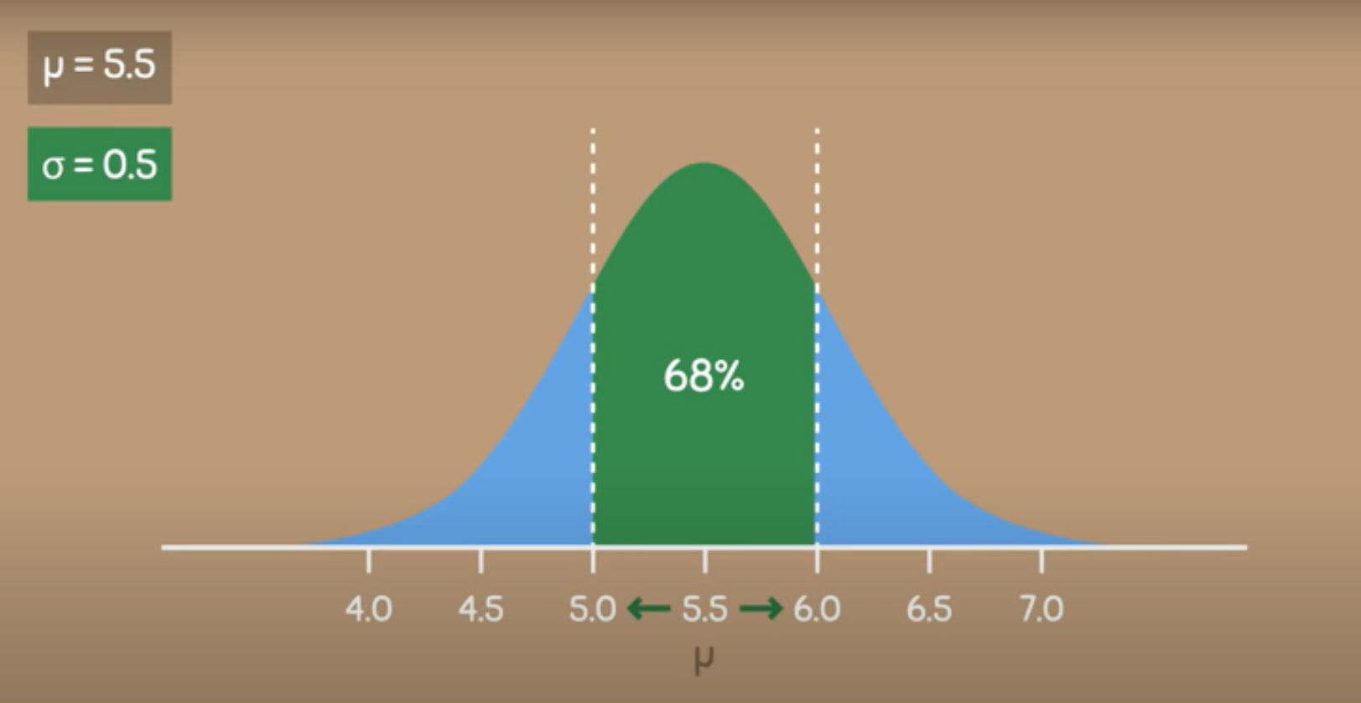

If we go two S.D away from the mean, it contains an area of 95%. This means that 95% of the people in the population have a height between 4.5 and 6.5 feet tall.

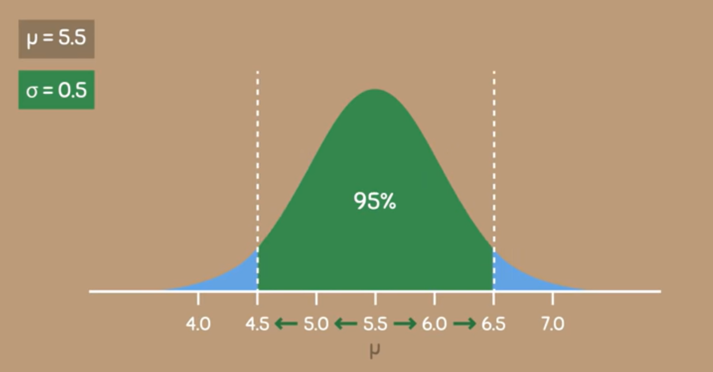

And finally with 3 S.D away from the mean it contains 99.7% of the area. This means that for the population we are studying 99.7% of the people are between 4 to 7 feet tall.

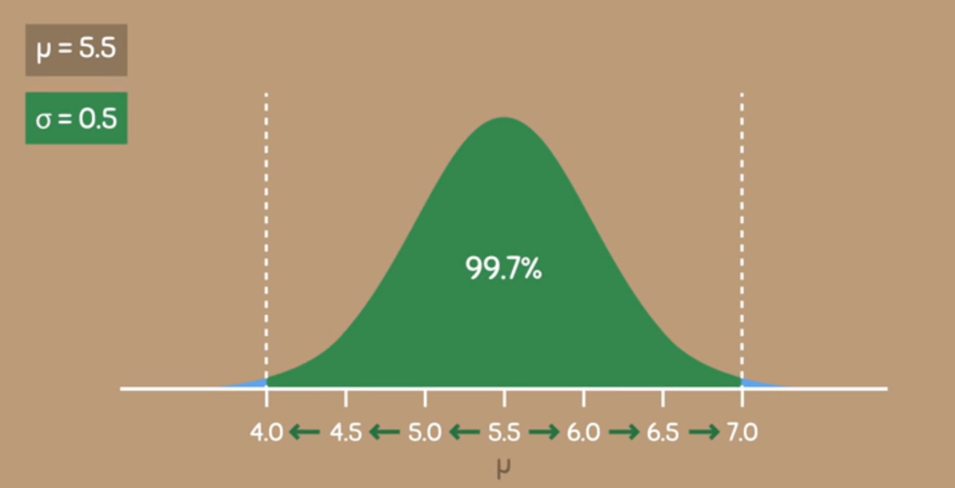

The values further away from the mean are less likely to occur.

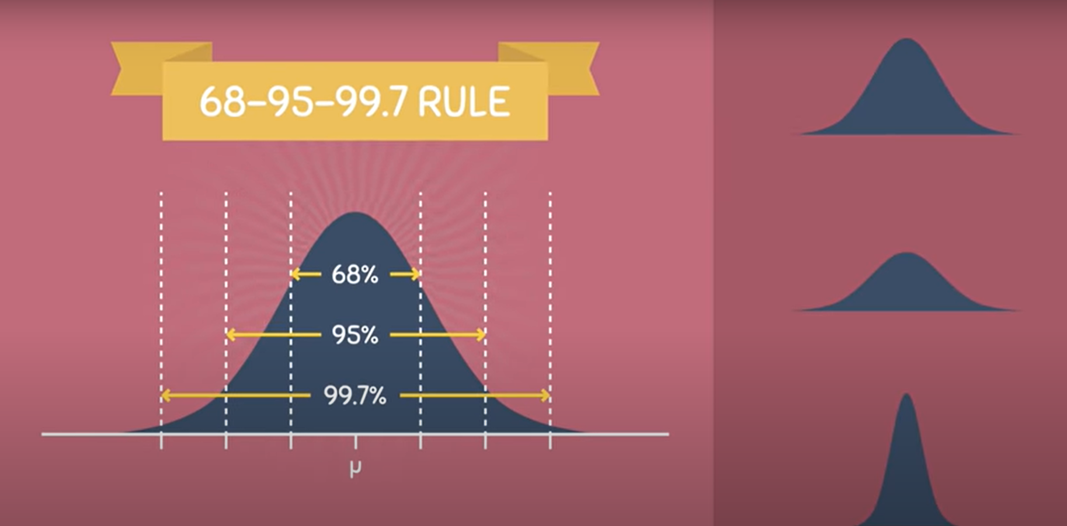

What happens if we go beyond 3 S.D’s like 4S.D, or 5 S.D or 6 S.D or so on..

A Normal Distribution never touches the X-axis, it continues on to infinity. We can go as many Standard Deviations away from the mean as we want. But the area contained within these regions will be very very small

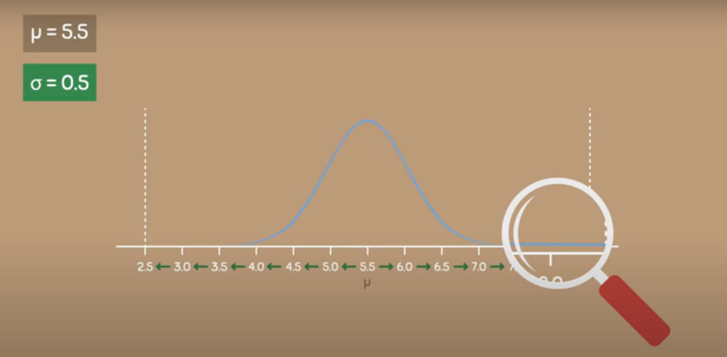

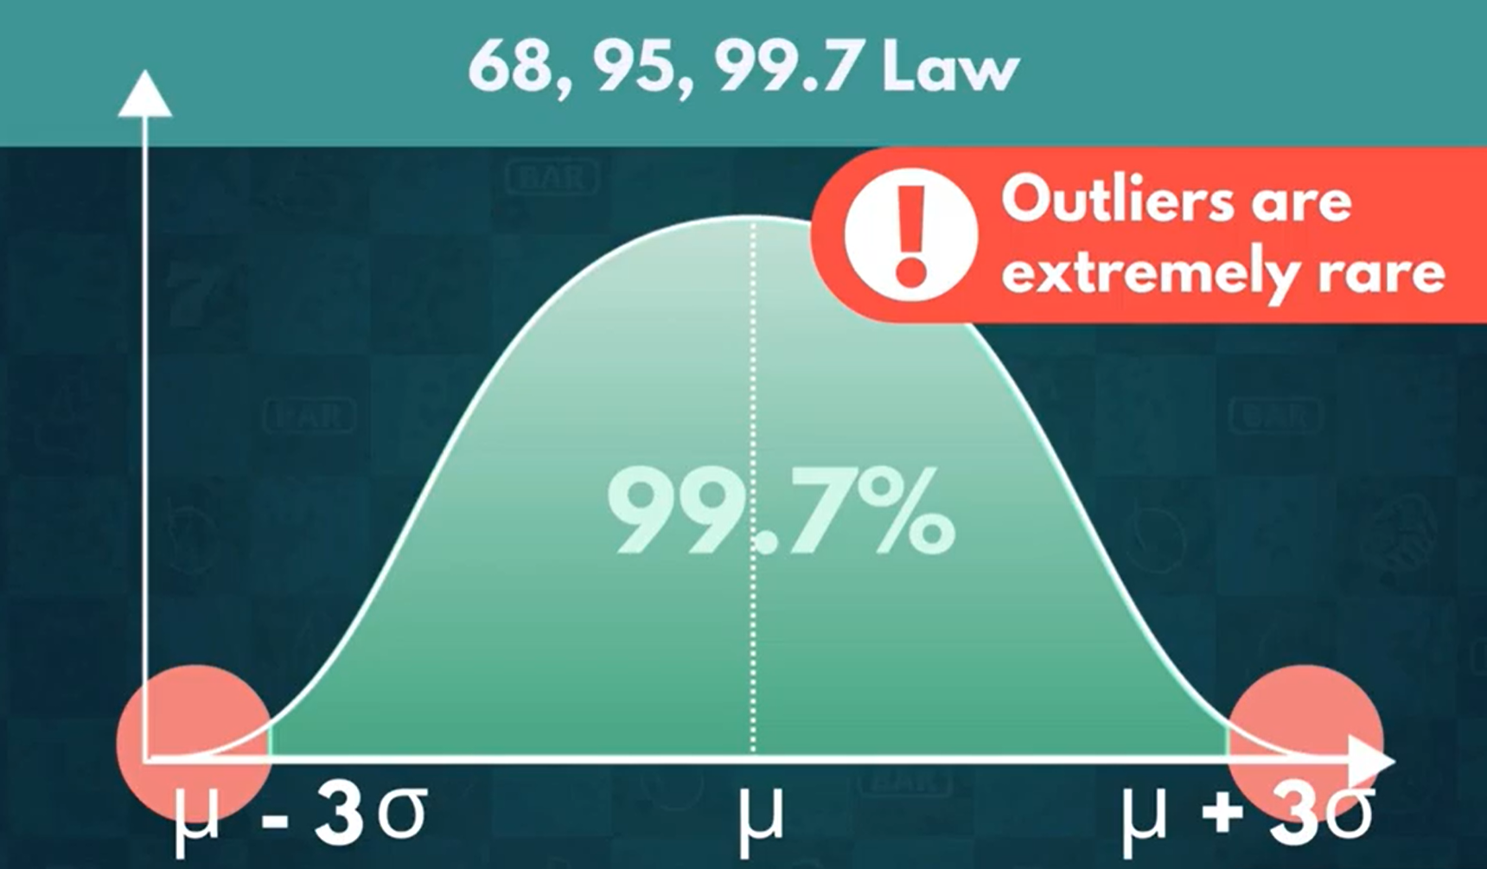

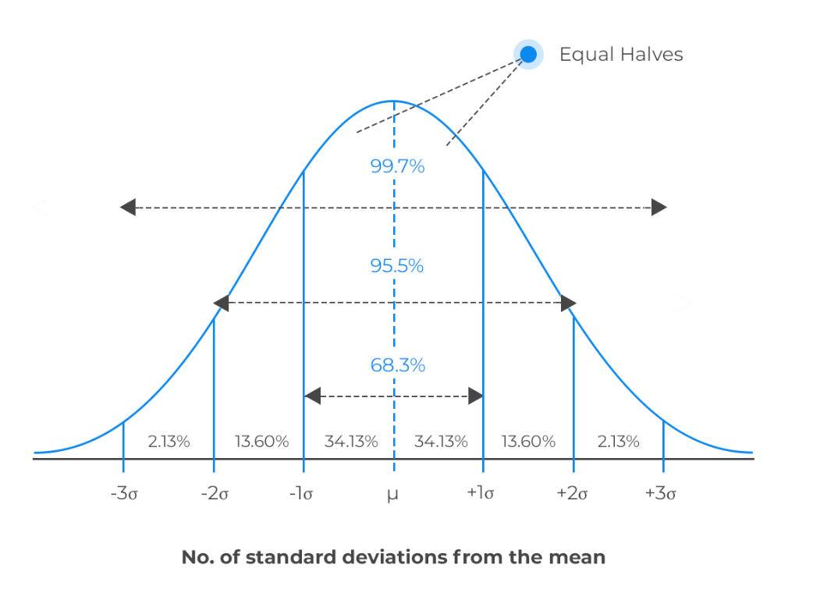

A normal distribution,bell curve, Gaussian Distribution

In a normal distribution, the mean is zero and the standard deviation is 1. It has zero skew.

Normal distributions are symmetrical, but not all symmetrical distributions are normal.

50% of the data lies towards L.H.S of the mean and 50% of the data lies towards R.H.S of the mean

The mean, median, and mode of a normal distribution are equal.

The area under the normal curve is equal to 1.0.

Normal distributions are denser in the center and less dense in the tails.

Normal distributions are defined by two parameters, the mean (μ) and the standard deviation (σ).

68% of the area of a normal distribution is within one standard deviation of the mean.

Approximately 95% of the area of a normal distribution is within two standard deviations of the mean.

In real-time most of the data is not normal. But most of the ML algorithms assume data is normal. more reliable predictions are made if the predictors(Input) and the target variable(output) are normally distributed.

**Third Moment Business Decision:**

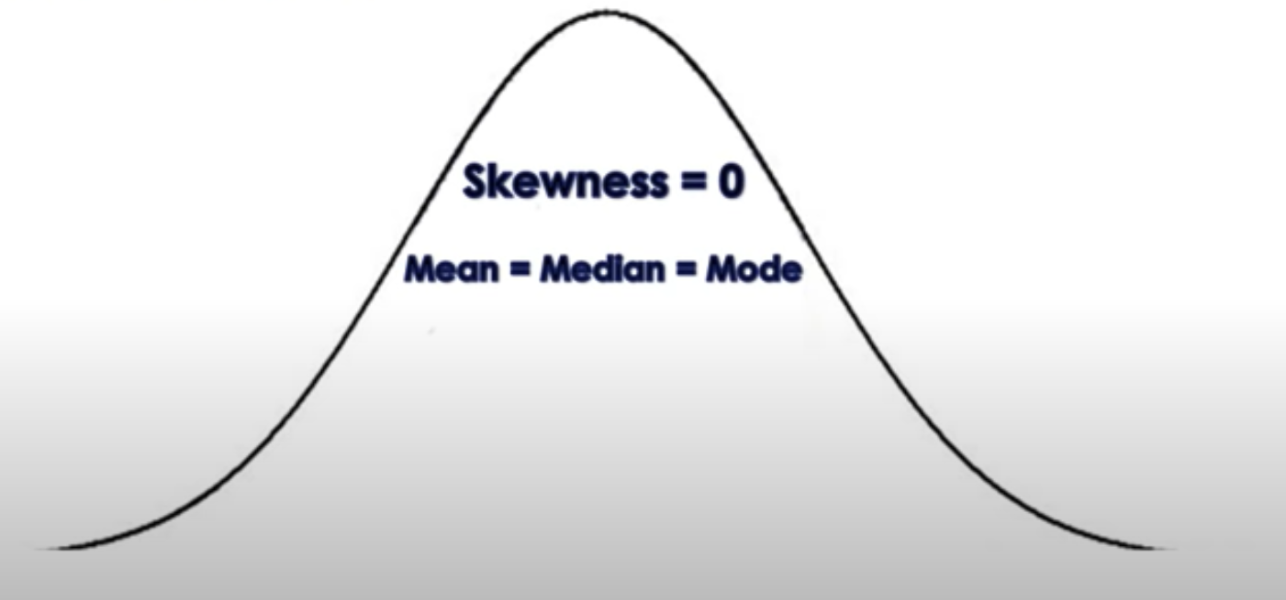

**Skewness(Long-Tail Concept)**

Skewness describes the asymmetry of a distribution. A skewed distribution therefore has one tail longer than the other.

A positively skewed distribution has a longer tail to the right:

A negatively skewed distribution has a longer tail to the left:

A distribution with no skew (e.g. a normal distribution) is symmetrical

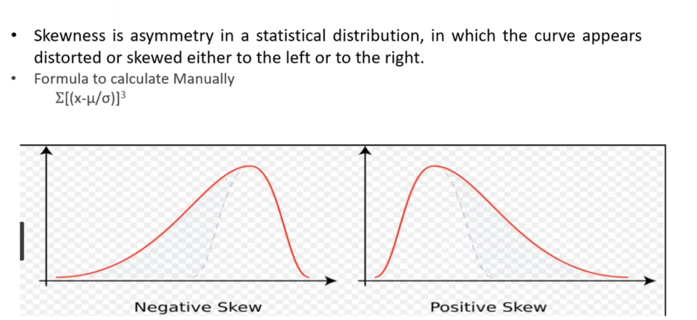

**Data Distribution with Positive Skewness:**

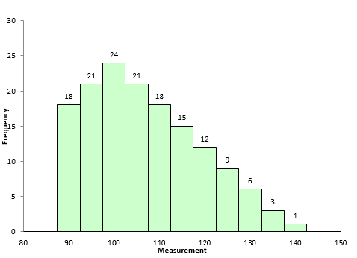

**Data Distribution with Negative Skewness:**

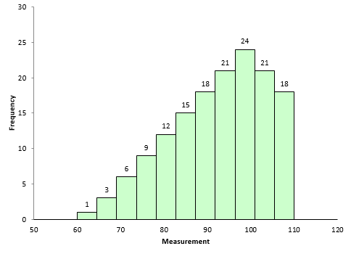

Profit, Employee Attrition, Manufacturing Defect Mobile Phones

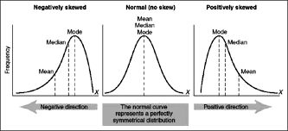

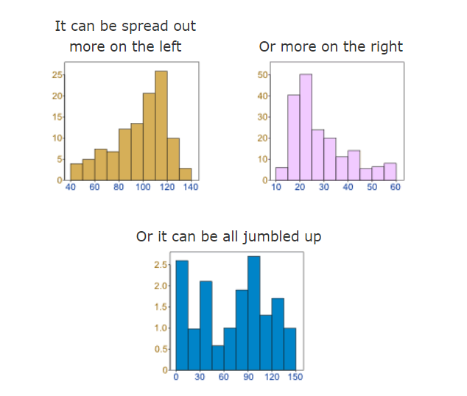

But there are many cases where the data tends to be around a central value with no bias left or right, and it gets close to a "Normal Distribution" like this:

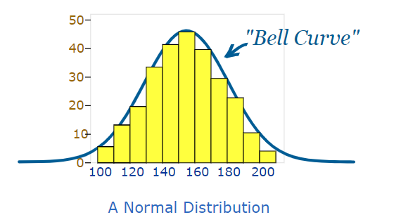

**Fourth Moment Business Decision: Kurtosis**

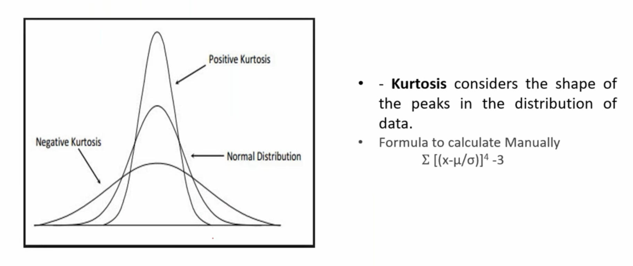

Kurtosis is a measure of the outlier (rare, extreme value) characteristic of a distribution or data.

**Positive Kurtosis:**

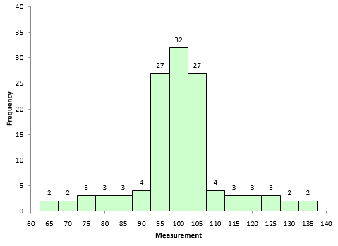

**Negative Kurtosis:**

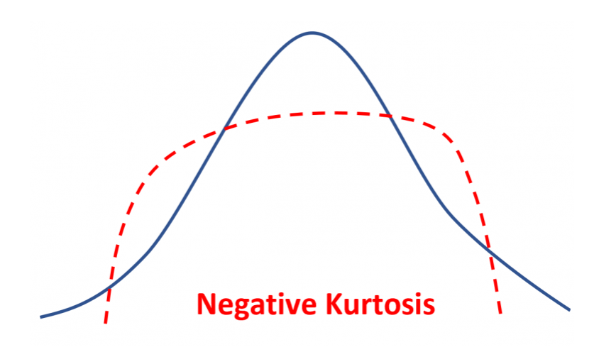

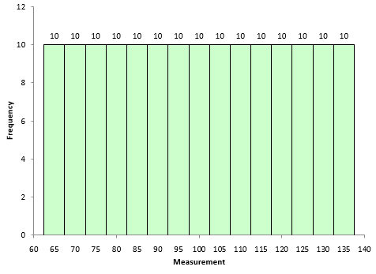

These two statistics give you insights into the shape of the distribution.

MEAN: where the center of the bell curve is

STANDARD DEVIATION: how wide the bell curve is

SKEW: how much the bell curve is “pushed over” to one side or the other so, rather than being perfectly symmetrical (skew=0), it’s “bunched up” on one side and has a longer tail on the other.

KURTOSIS: how steeply or softly the bell curve comes to it’s “point”

**Standard Normal Distribution:**

As we’ve seen above, the normal distribution has many different shapes depending on the parameter values. However, the standard normal distribution is a special case of the normal distribution where the mean is zero and the standard deviation is 1. This distribution is also known as the Z-distribution.

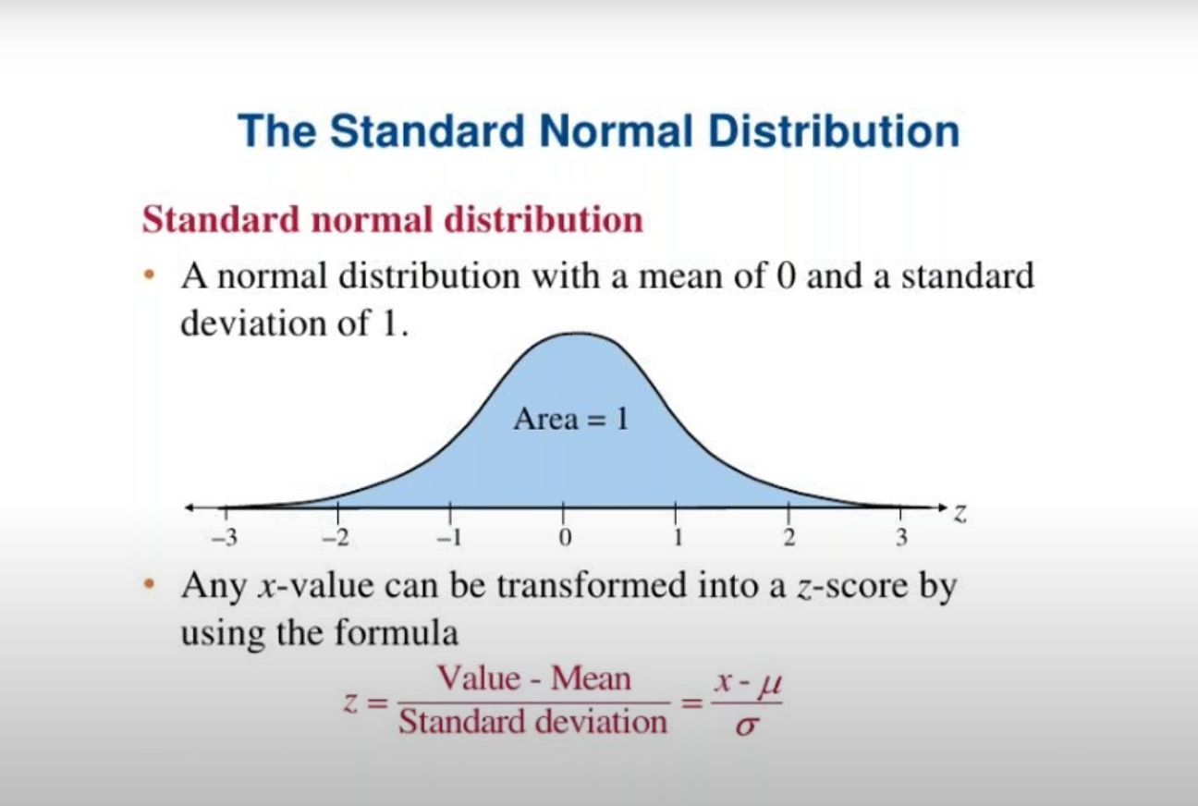

In order to enable comparison we need to unitize the deviations , that is we have to express the deviation from the mean per unit sd.

By this, we are calculating a quantity called z score by scaling the deviations.The resulting deviation per unit sd therefore has sd =1 and mean =0 ,which is usual if the data comes from normal distribution.

Example:Before Scaling

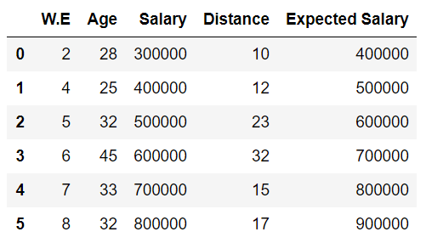

We assume the data is following Normal Distribution, but could not compare one column with another because of unit issues and scaling issues. To make the data unitless, we are converting the Normal Distribution to Standard Normal Distribution.

After Scaling:

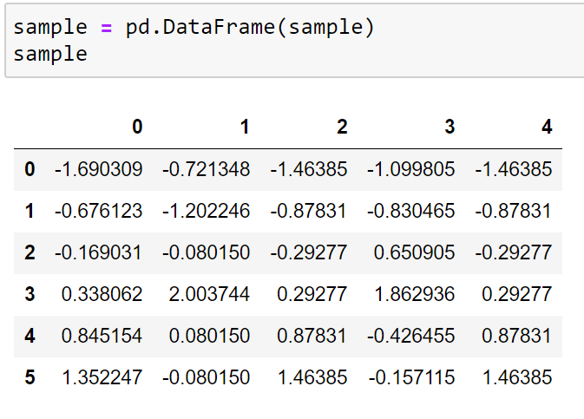

So to make conclusions like this we need to convert Normal distribution into Standard Normal as comparison without a common base will serve no purpose.

**Box Plot:**

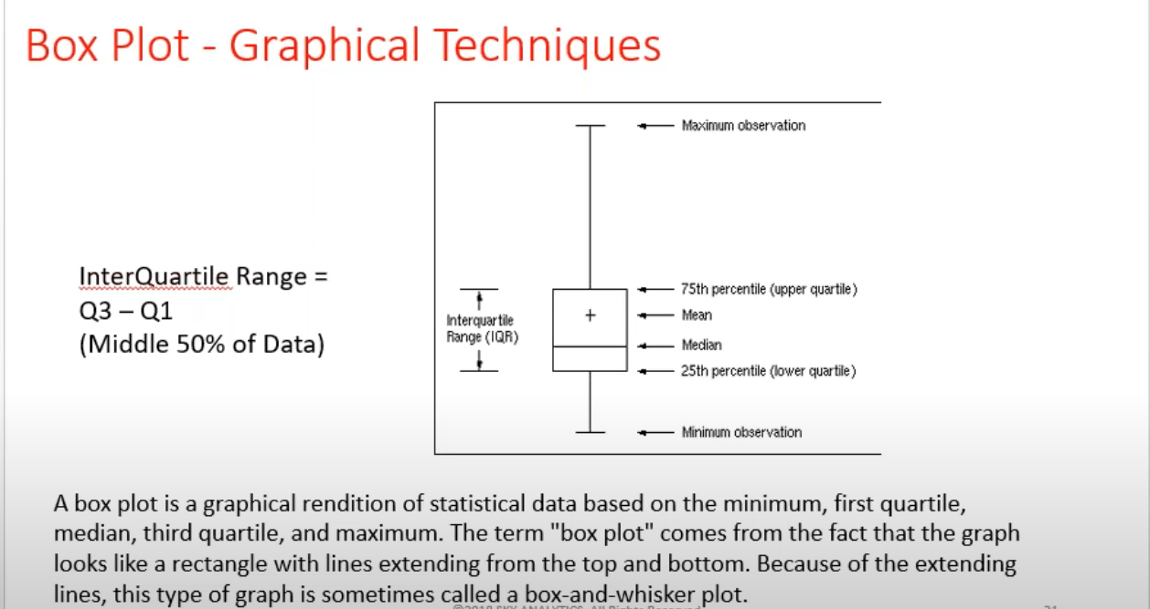

If we want to calculate the numbers within the box, We need to calculate the IQR(Interquartile Range) = Q3 - Q1

**Box Plot is also called as Five Number Summary:**

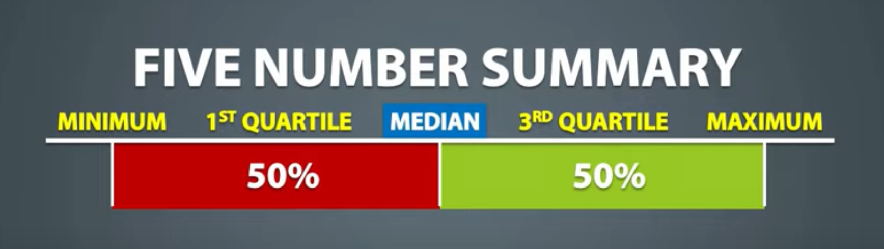

Example: 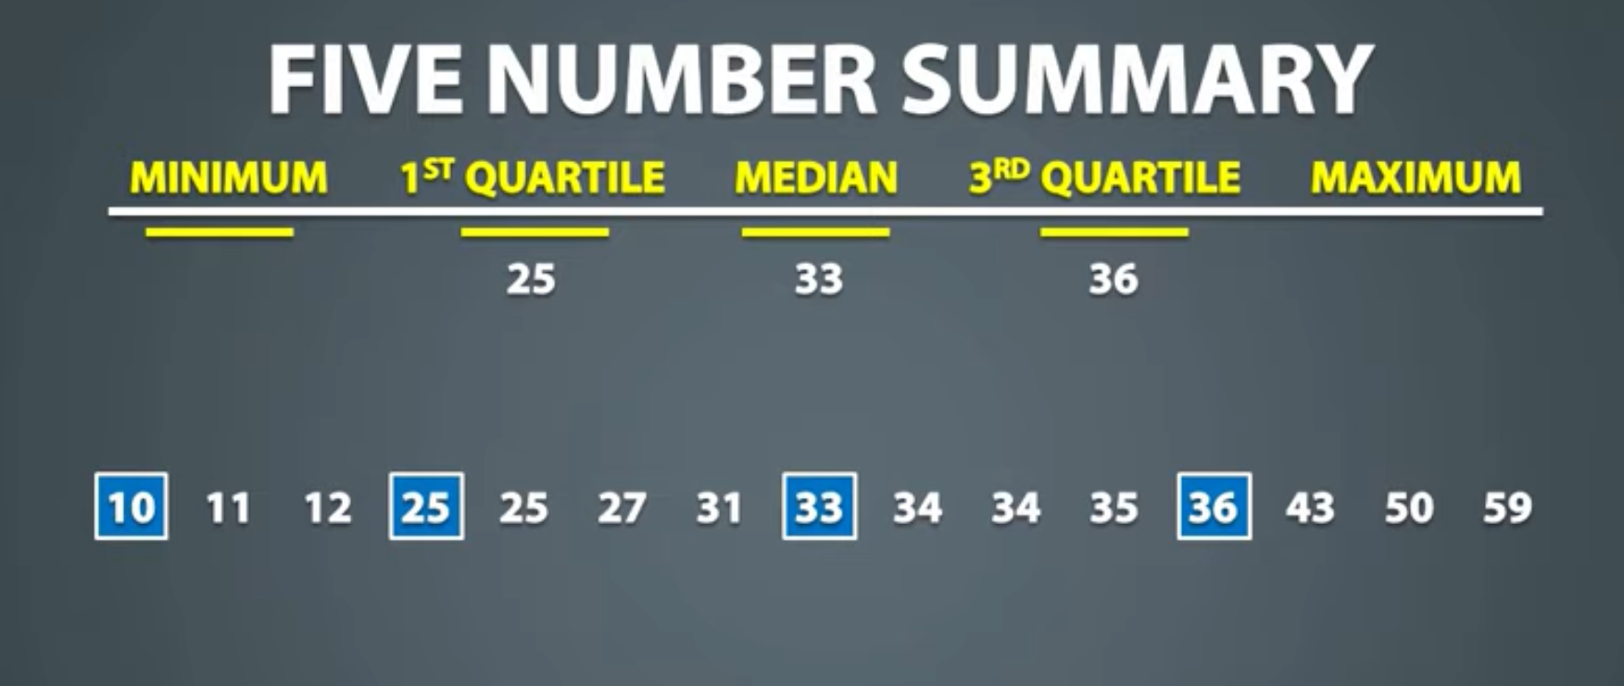

Q1 = 25

Median(Q2) = 33

Q3 = 36

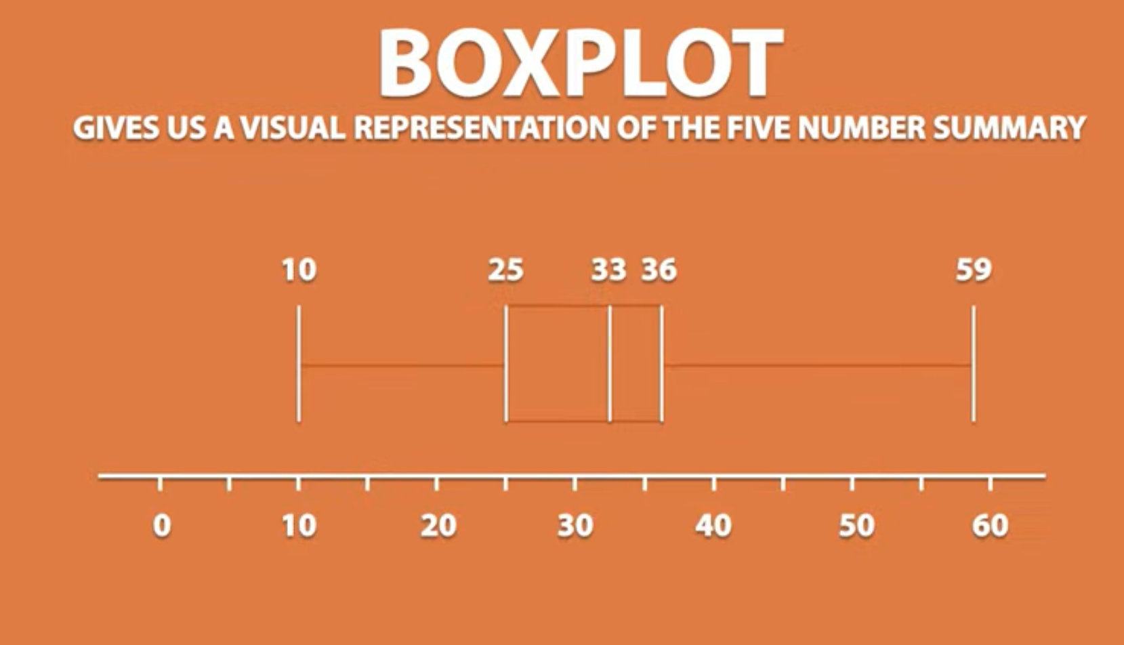

To check for outliers using Box Plot: we use the formula :

Data Point < Q1 - 1.5(IQR) or Data Point > Q3 + 1.5(IQR)

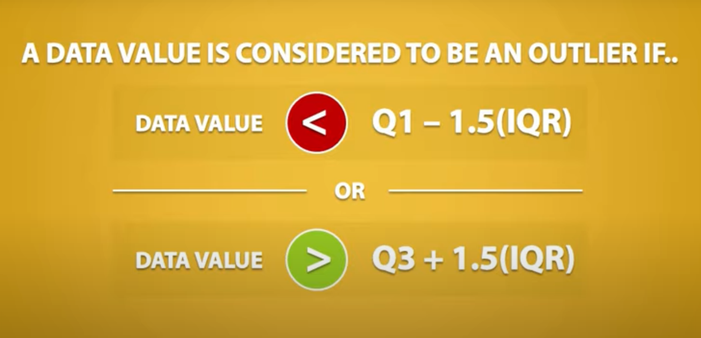

Computing InterQuartile Range:

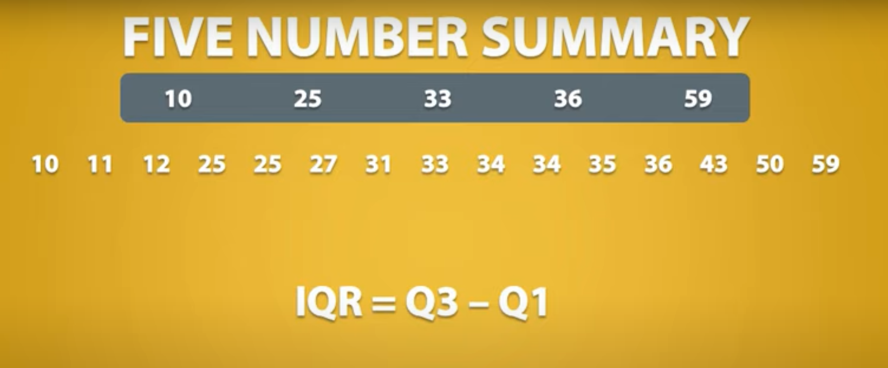

Computing Outliers:

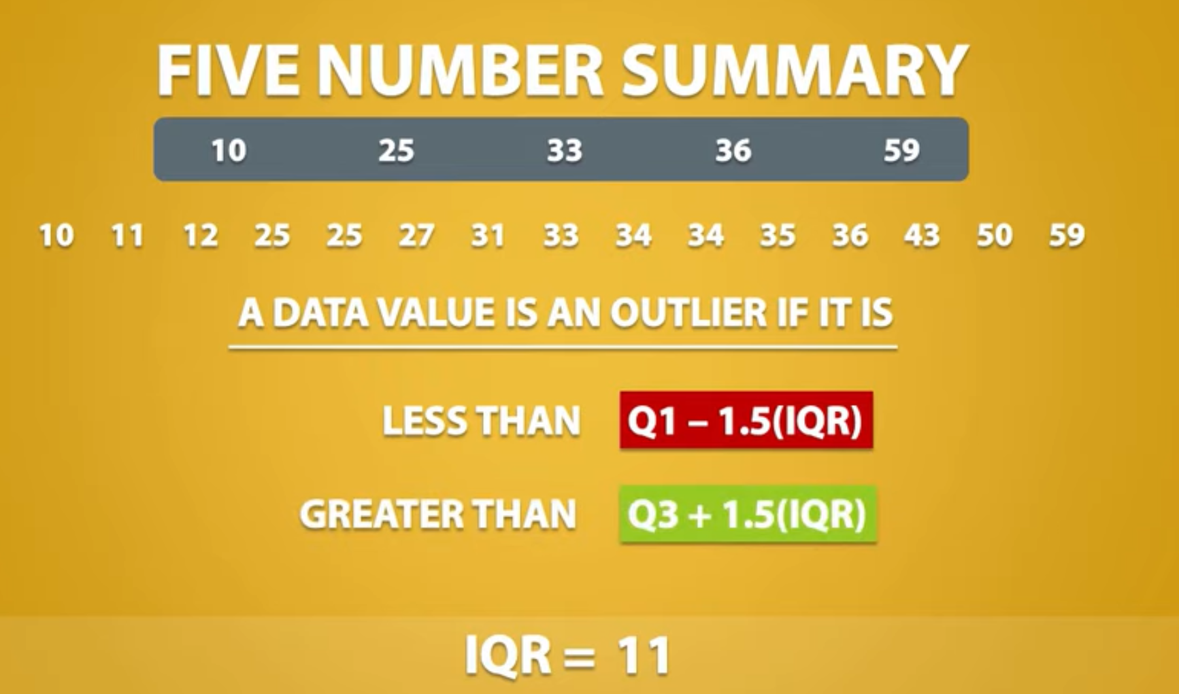

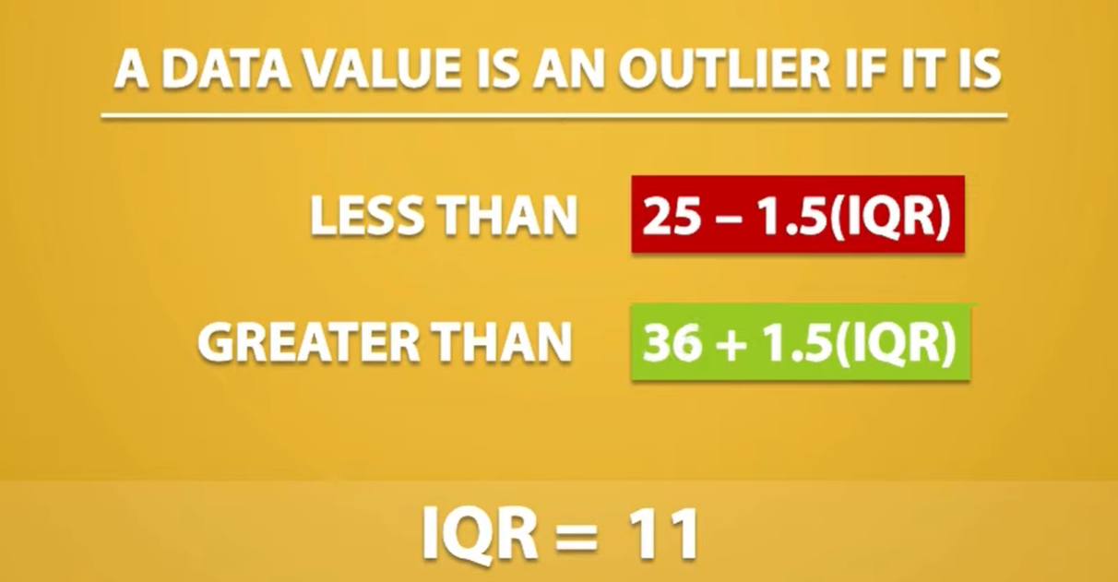

We do not have any value, which is less than 8.5. However, we have a value which is greater than 52.5. So, 59 is considered as an outlier.

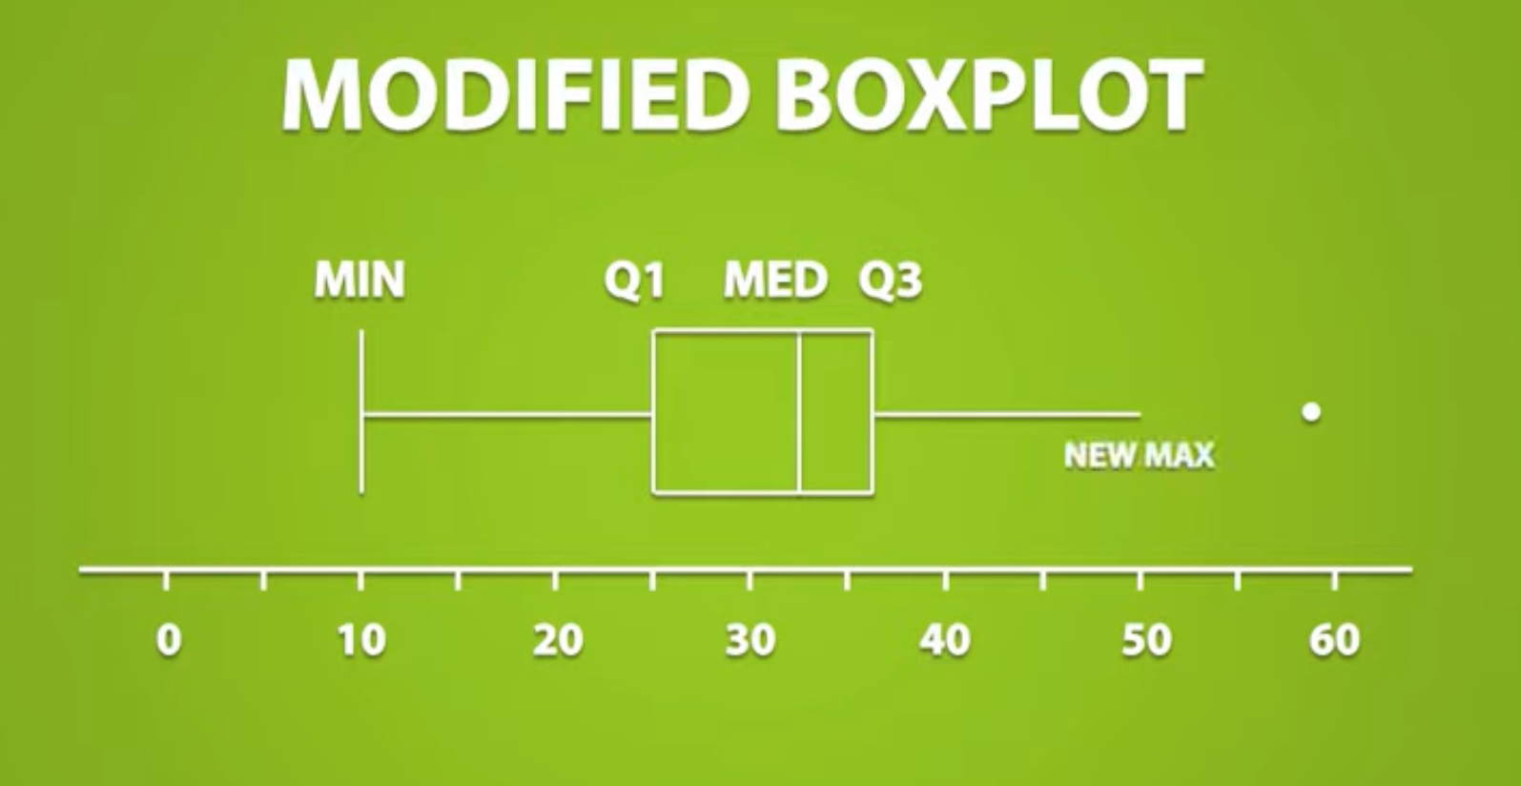

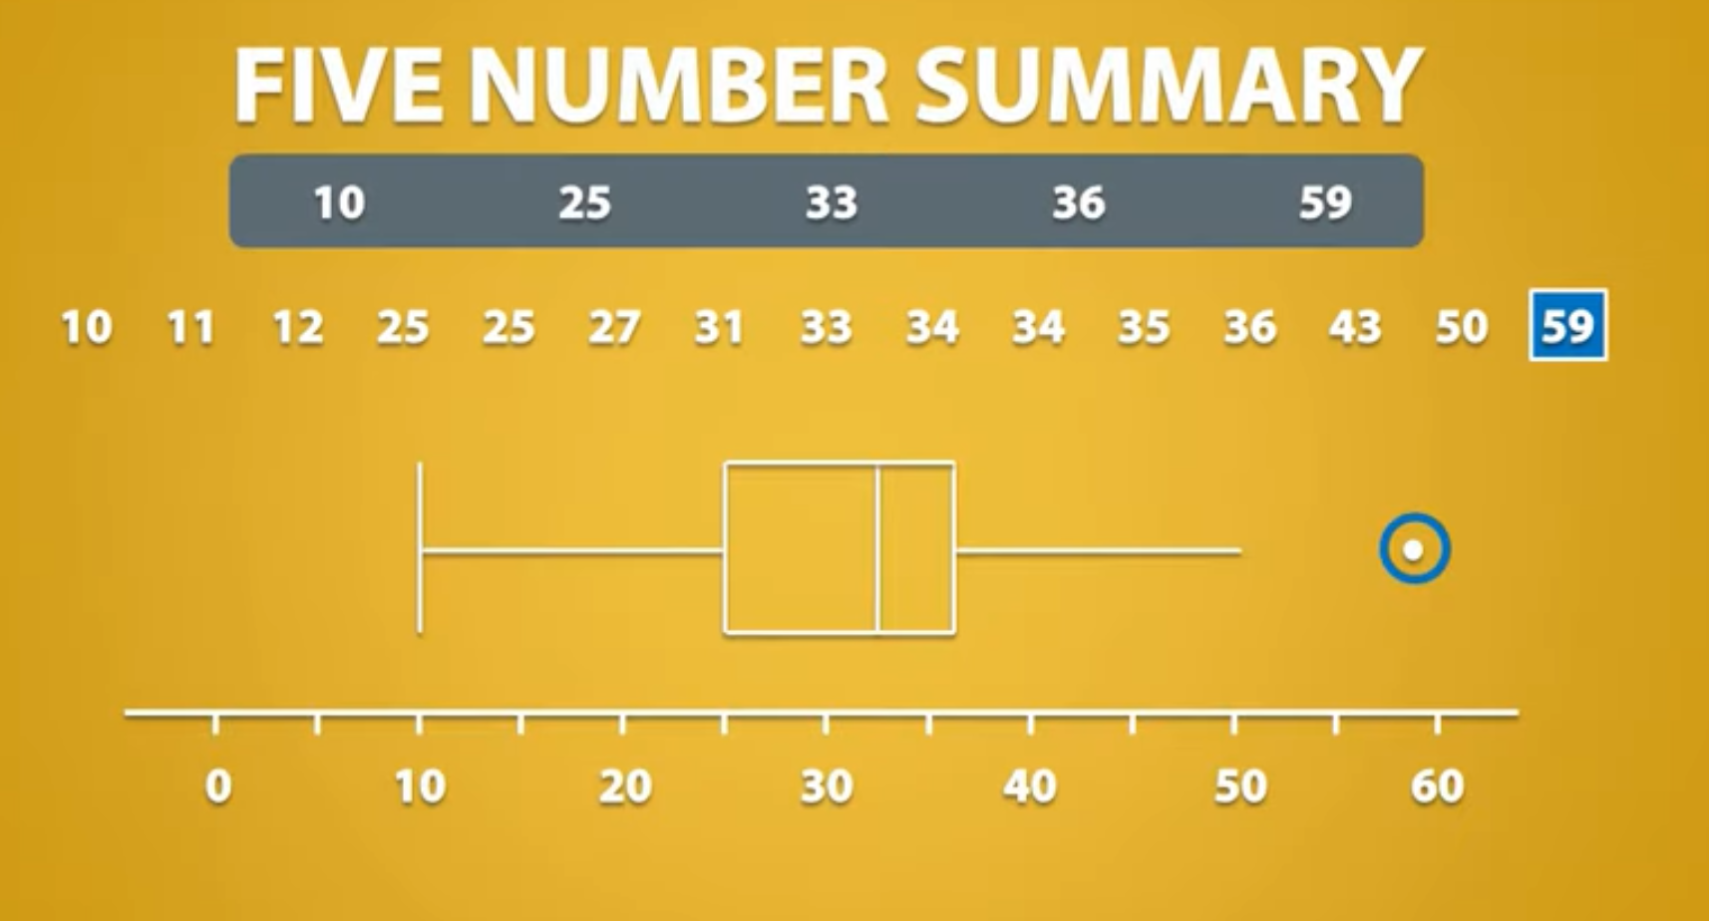

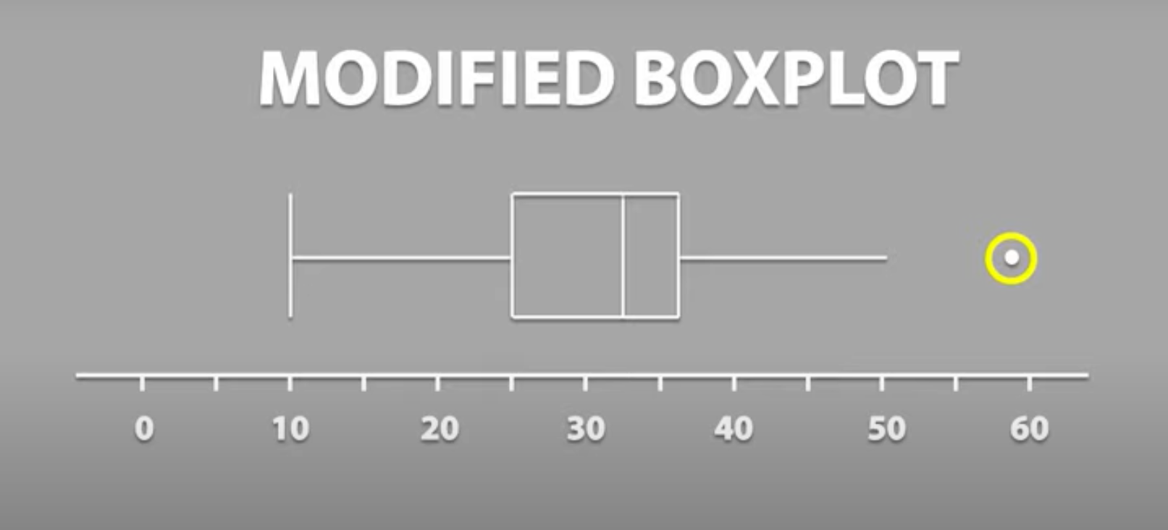

**Types of Data:**

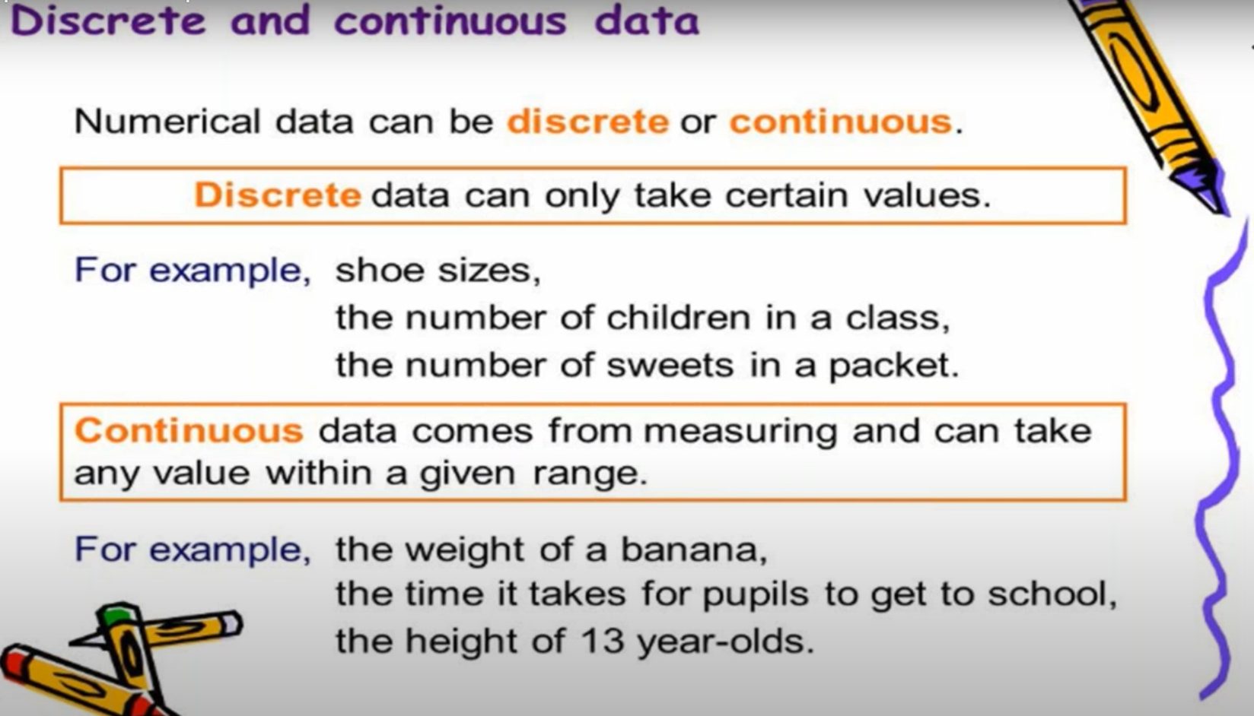

**Continuous Data**:

**Continuous data** are not restricted to defined separate values, but can occupy any value over a continuous range. Between any two continuous data values, there may be an infinite number of others. **Continuous data are always essentially numeric**.If the data is expressed in some decimal format and which should have a meaning.

Continuous data comes from measuring and can take any value within a given range. It contains decimal value.

Examples: Time - 1hour 25 mins

Distance - 1.4 km, 2.5km

Petrol Price - 150.75 Rupees, etc.,

**Discrete Data**::

Discrete data, also called as categorical data. Discrete data can be numerical or categorical.

If the data is expressed in decimal format and which does not have any meaning. It can take only particular values.

Example: 1 laptop, 2 laptops, 3 cars, 4 ice-creams.

Discrete data can be **numeric** -- like numbers of apples -- but it can also be **categorical** -- like red or blue, or male or female, or good or bad.